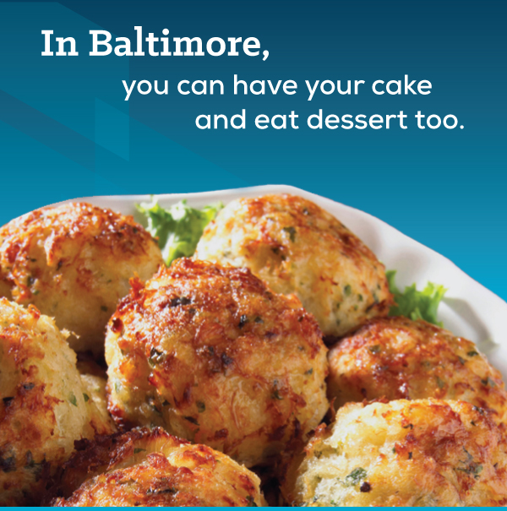
From world-class dining to eclectic cuisine, Baltimore has restaurants to satisfy every palate. But the crab cake is Baltimore’s signature dish. You can’t visit here without eating one. Or two. Or three.
Expect a full “plate” of professional development sessions plus fun events (including a fireworks show at the Inner Harbor) during the NGAUS 138th General Conference/Expo 9-12 September Baltimore, Md. A three day concert of musicians & soloists will “keep the conference rocking”. You may even win tickets to the Ravens/Bills season opener on 9/11.
Presidential candidates come to the NGAUS conference. Witness historic moments, learn the way ahead from senior leaders, plus connect with your peers nationwide.
To learn more about Conference/ Social Events: www.ngaus.org/ngaus2016
For industry sponsorship opportunities / housing options: ngaus2016@epponline.com 410 997-0763 Fax 410 997 0764

