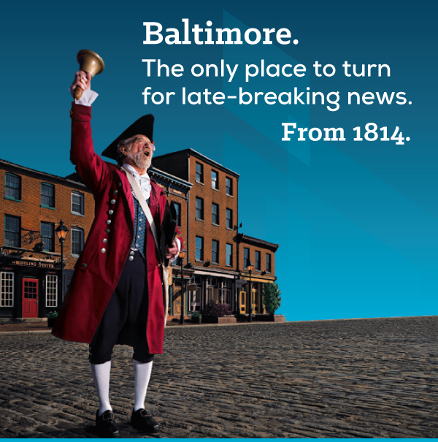
The Town Crier strides across the cobblestones in historic Fell’s Point to deliver news from the Battle of Baltimore. He tells of the British invasion, the defense of Ft McHenry, & the victory that inspired Francis Scott Key to gaze across the harbor and pen the Star-Spangled Banner. Baltimore’s past comes to life in the present.
“Squire Frederick” will greet you at the NGAUS 138th General Conference/Expo 9-12 September Baltimore, Md. A three day concert of musicians & soloists will “keep the conference rocking”. You may even win tickets to the Ravens/Bills season opener on 9/11.
Presidential candidates come to the NGAUS conference. Witness historic moments, learn the way ahead from senior leaders, plus connect with your peers nationwide.
Conference/ Social Events: www.ngaus.org/ngaus2016
For industry sponsorship opportunities / housing options: ngaus2016@epponline.com 410 997-0763 Fax 410 997 0764

